VISHWAKARMA UNIVERSITY
Academic Year: 2025-26 | Semester II
ADVANCED WEB TECHNOLOGY
NAME OF THE STUDENT : | Aaditya Dhanwate
DEPARTMENT : | ARTIFICIAL INTELLIGENCE & DATA SCIENCE
CLASS / DIV. : | TY / A
SRN : | 31230319
ROLL NO. : | 8

ASSIGNMENT NO.: 02
Create Forms with Validation using AngularJS
OBJECTIVE:
• Build a user registration form using AngularJS
• Implement real-time field-level validation (email, phone, password)
• Display inline error messages and control form submission state

Problem Statement: Using AngularJS, create a User Registration form that validates Full Name, Email Address, Phone Number, and Password fields. The form should show real-time error messages for invalid inputs and enable the Register button only when all fields are valid.

Output:
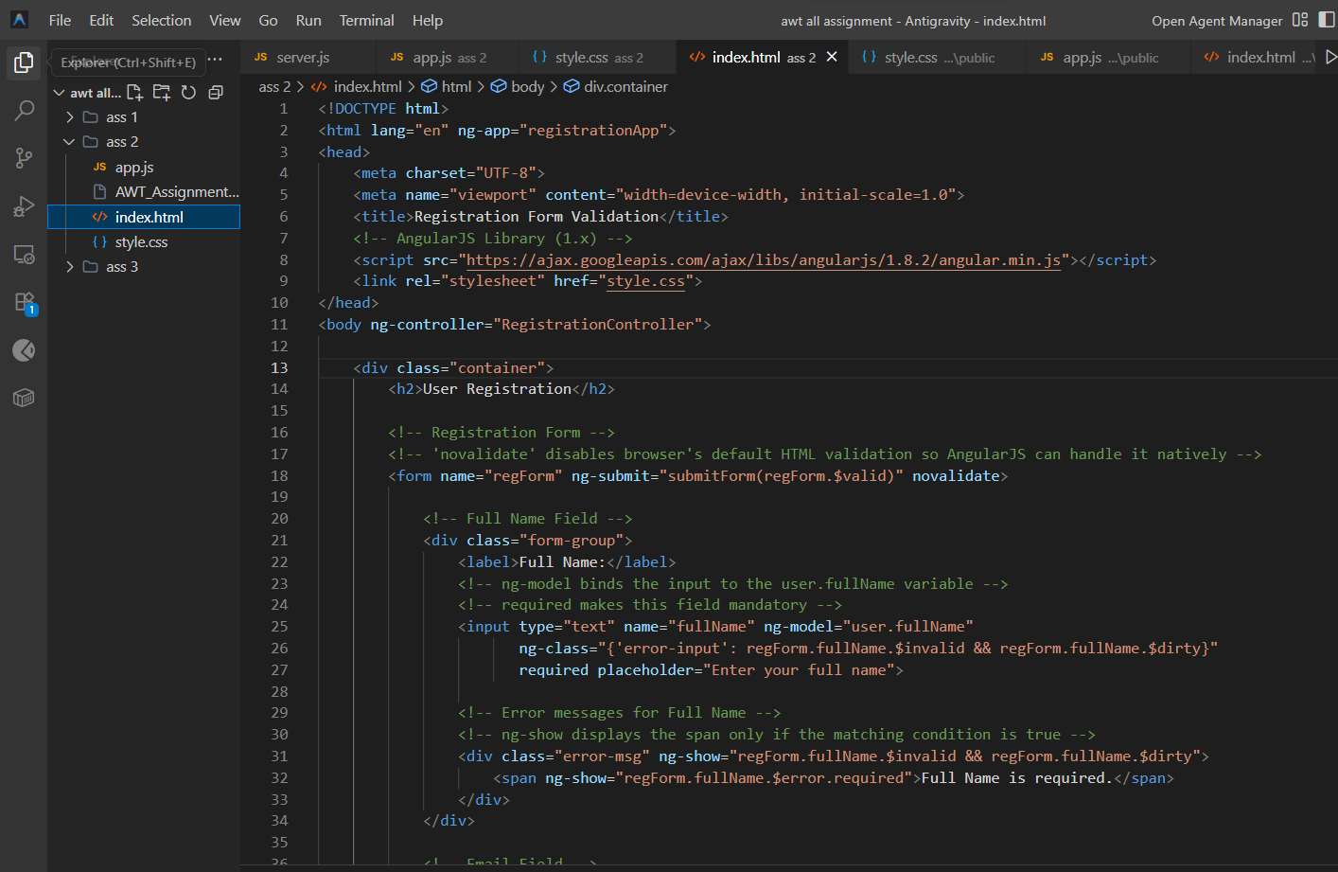
1. Form with Validation Errors (Invalid Email, Phone & Short Password):
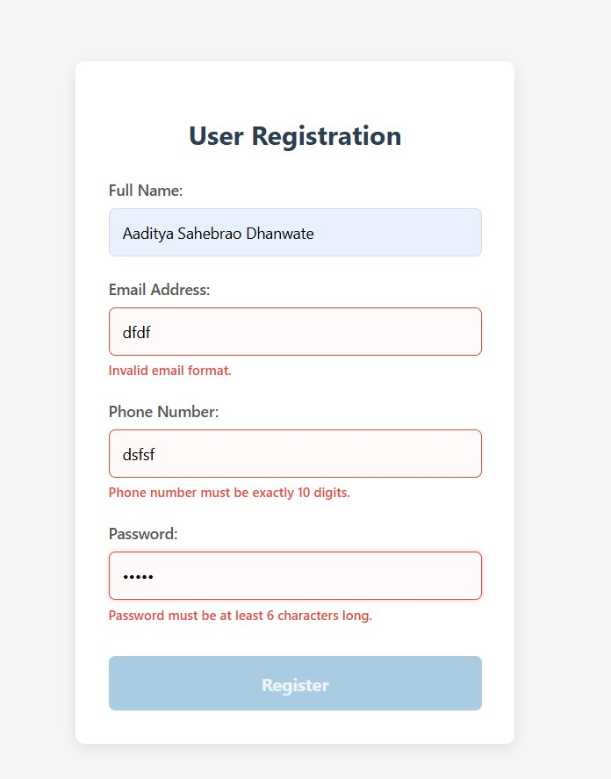
2. Form with All Valid Inputs (Register Button Active):
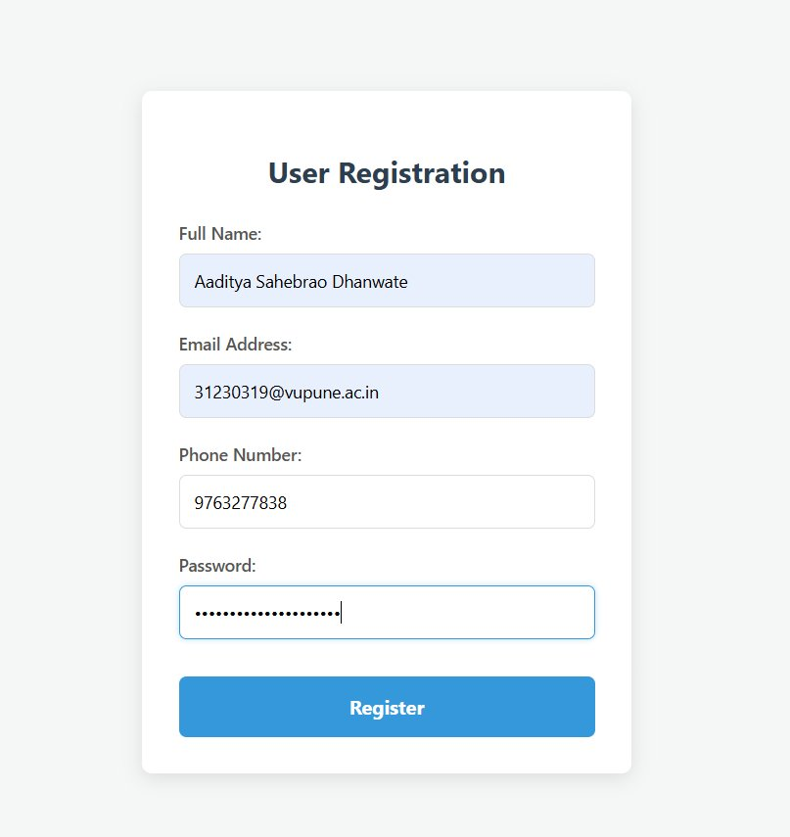

Conclusion:
In this assignment, a User Registration form was successfully created using AngularJS with comprehensive client-side validation. The form validates the email format, enforces a 10-digit phone number, and requires a minimum password length of 6 characters. Error messages are displayed in real-time using AngularJS directives such as ng-show and ng-class, and the Register button is disabled until all fields pass validation, ensuring a clean and user-friendly experience.

